Team:  Date: |  | 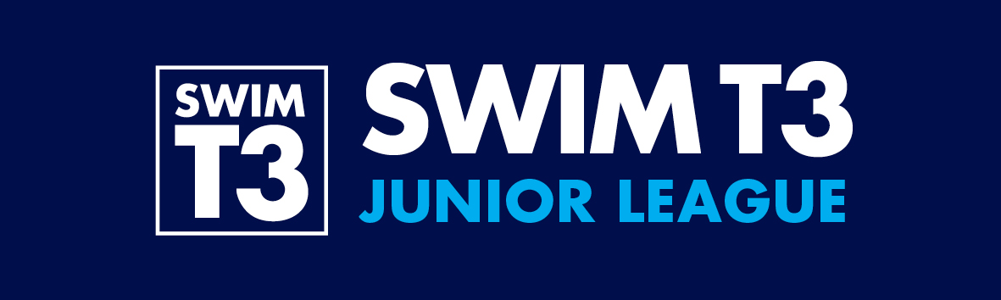  2013 Swim T3  Junior League – Term 1  Programme of Events  Round 2 – 9th March  Round 4 – 6th April
Team Manager Sheet 2 (Rounds 2 & 4)
Event No. | Category |  | Event | Name
1 | Girls C2 |  | 1 Length Freestyle
2 | Boys C2 |  | 1 Length Freestyle
3 | Girls C1 |  | 1 Length Breaststroke
4 | Boys C1 |  | 1 Length Breaststroke
5 | Girls C3 |  | 4 x 1 length Medley Relay | BK
5 |  |  | 4 x 1 length Medley Relay | BR
5 |  |  | 4 x 1 length Medley Relay | FLY
5 |  |  | 4 x 1 length Medley Relay | FR
6 | Boys C3 |  | 4 x 1 length Medley Relay | BK
6 |  |  | 4 x 1 length Medley Relay | BR
6 |  |  | 4 x 1 length Medley Relay | FLY
6 |  |  | 4 x 1 length Medley Relay | FR
7 | Girls C4 |  | 2 Length Backstroke
8 | Boys C4 |  | 2 Length Backstroke
9 | Girls C2 |  | 1 Length Breastroke
10 | Boys C2 |  | 1 Length Breastroke
11 | Mixed C1 |  | 4 x 1 length Medley Relay | BK
11 |  |  | 4 x 1 length Medley Relay | BR
11 |  |  | 4 x 1 length Medley Relay | FLY
11 |  |  | 4 x 1 length Medley Relay | FR
12 | Girls C4 |  | 1 length Butterfly
13 | Boys C4 |  | 1 length Butterfly
14 | Girls C3 |  | 2 Length Backstroke
15 | Boys C3 |  | 2 Length Backstroke
16 | Girls C4 |  | 2 Lengths Breaststroke
17 | Boys C4 |  | 2 Lengths Breaststroke
18 | Girls C2 |  | 4 x 1 Length Freestyle Relay
19 | Boys C2 |  | 4 x 1 Length Freestyle Relay
CONTINUED OVER

Event No. | Category |  | Event | Name
20 | Girls C3 |  | 1 Length Butterfly
21 | Boys C3 |  | 1 Length Butterfly
22 | Girls C1 |  | 1 Length Butterfly
23 | Boys C1 |  | 1 Length Butterfly
24 | Girls C4 |  | 2 Lengths Freestyle
25 | Boys C4 |  | 2 Lengths Freestyle
26 | Girls C2 |  | 1 Length Backstroke
27 | Boys C2 |  | 1 Length Backstroke
28 | Girls C1 |  | 1 Length Freestyle
29 | Boys C1 |  | 1 Length Freestyle
30 | Girls C4 |  | 4 x 1 length Freestyle Relay
31 | Boys C4 |  | 4 x 1 length Freestyle Relay
32 | Girls C3 |  | 2 Lengths Breastroke
33 | Boys C3 |  | 2 Lengths Breastroke
34 | Girls C2 |  | 1 Length Butterfly
35 | Boys C2 |  | 1 Length Butterfly
36 | Girls C1 |  | 1 Length Backstroke
37 | Boys C1 |  | 1 Length Backstroke
38 | Girls C3 |  | 2 Lengths Freestyle
39 | Boys C3 |  | 2 Lengths Freestyle
40 | Mixed C4 |  | 4 x 2 lengths Medley Relay | BK
40 |  |  | 4 x 2 lengths Medley Relay | BR
40 |  |  | 4 x 2 lengths Medley Relay | FLY
40 |  |  | 4 x 2 lengths Medley Relay | FR
41 | Mixed Canon Relay |  | 8 x 1 length Freestyle Relay

