Chris Moller
Chairman
Appointments Panel - Swimming New Zealand Board appointments

12 October 2012

To: the Swimming New Zealand membership and community

I am delighted to announce that Bruce Cotterill and Geoff Brown have been appointed to the board of Swimming New Zealand. Brief biographies on Bruce and Geoff are available on the Swimming NZ website for your information.

The appointment of Bruce and Geoff completes the board appointment process as set out in rule 12 of the constitution. The Inaugural Board members of Swimming New Zealand under rule 27 of the constitution are:

- Brent Layton (Wellington); Board Chair – 3 year term
- Gabrielle Rush (Auckland); elected member – 3 year term
- Clive Power (Pleasant Point); elected member – 2 year term
- Ian Hunt (Christchurch); elected member – 1 year term
- Bruce Cotterill (Auckland); appointed member – 2 year term
- Geoff Brown (Wellington); appointed member – 1 year term

The Inaugural Board members commence their role on 12 October 2012, at which point Sue Suckling's role as Governance Administrator will cease also. I'd like to take this final opportunity to thank Sue for the very significant contribution she has made in helping Swimming New Zealand get to this point.

I am confident that there is now a very strong, capable and complementary team in place to govern the sport through the challenging times ahead. I urge the Swimming New Zealand membership and community to work positively with the board to bring about the changes needed to make swimming the strong, cornerstone sport it should be in New Zealand. Finally, I wish you all the very best in your endeavours to do so.

With best wishes,
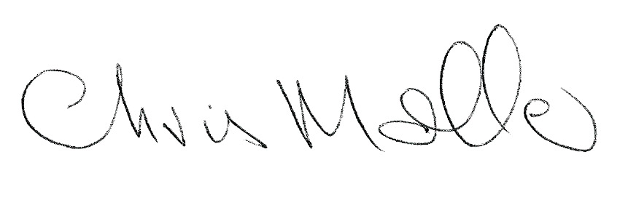
Chris Moller

